**DAY 10 LIT ASSIGNMENT**

**Name : Abdul Sameerunnisa**

**ID : 46247725**

**Assignment 3 – Business Add in (BADI)-Single Use**

**Hint:**

1. **SE18 should be used to define a BADI**
2. **SE19 should be used to implement the BADI Definition.**

**Requirement:** Define and implement a custom BADI in SE18 to divide two numbers.

Step1: Define a BADI (ZBADI_DEMO_01…05) in SE18.

Step2: Double click on the interface created to define the methods, parameters and exceptions.

Step3: Define an instance method DIVIDE_NUMBERS.

Step4: Define two importing parameter’s (I_NUM1 & I_NUM2) and one exporting parameter (E_RESULT) of type integer

Step5: Define an exception if division is carried out using null value.

Step6: Create an implementation (ZBADI_DEMO_IMP_01...05) by specifying the BADI name that was created in step1.u

Step7: Double click on the method and write the source code to divide the two numbers.

Step8: Create a wrapper program (ZDEMO_BADI_01…05).

Step9: Define a reference variable of type BADI interface.

Step10: Define selection screen with two parameters of type integers

Step11: Call method GET_INSTANCE of the class CL_EXITHANDLER to get the BADI instance

Step12: Call method DIVIDE_NUMBERS using this instance and pass the two selection parameters.

**BADI : Z7725BADI**

**Report : ZAS_LIT_DAY10_Q3**

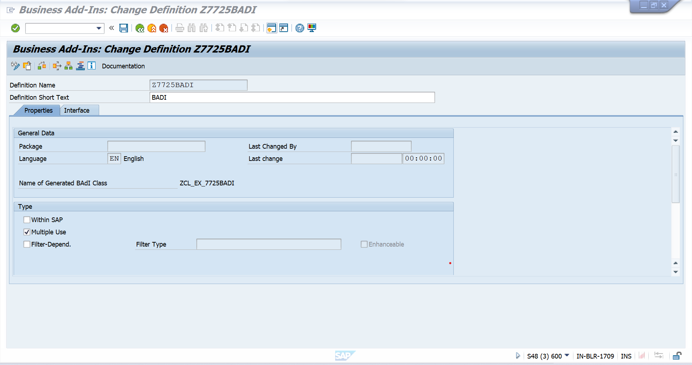

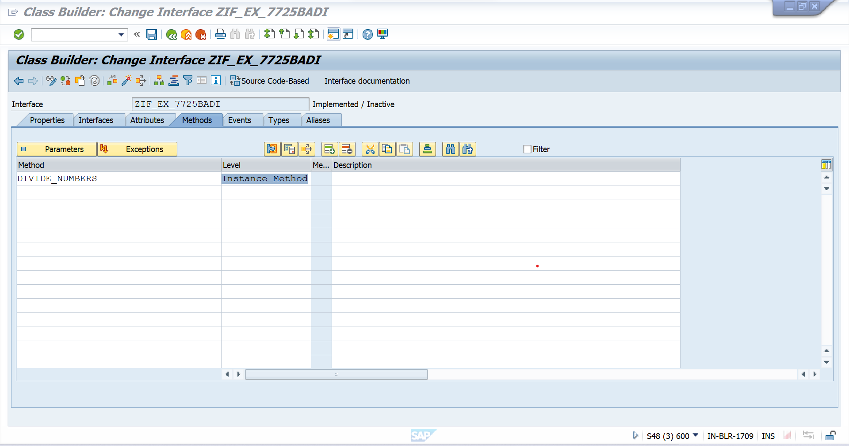

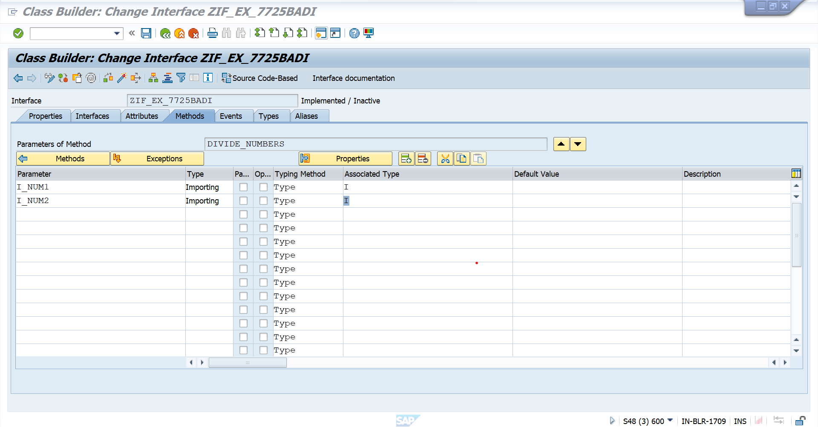

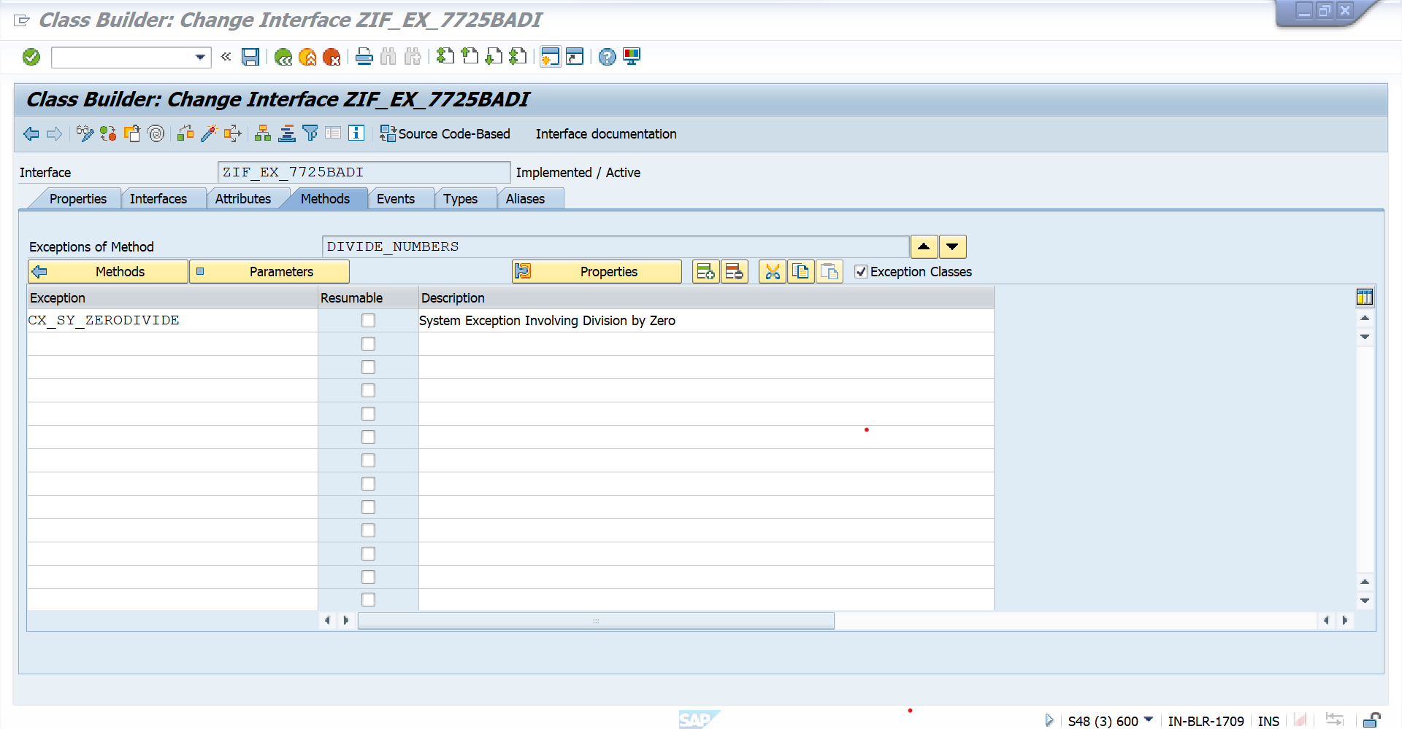

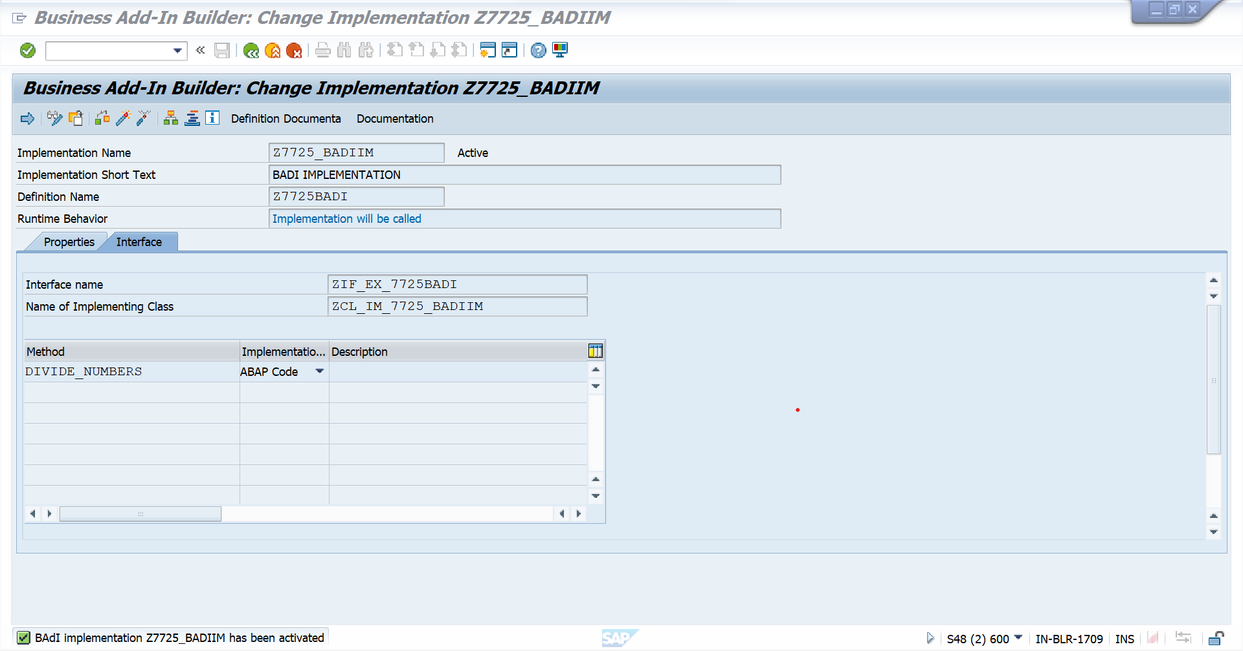

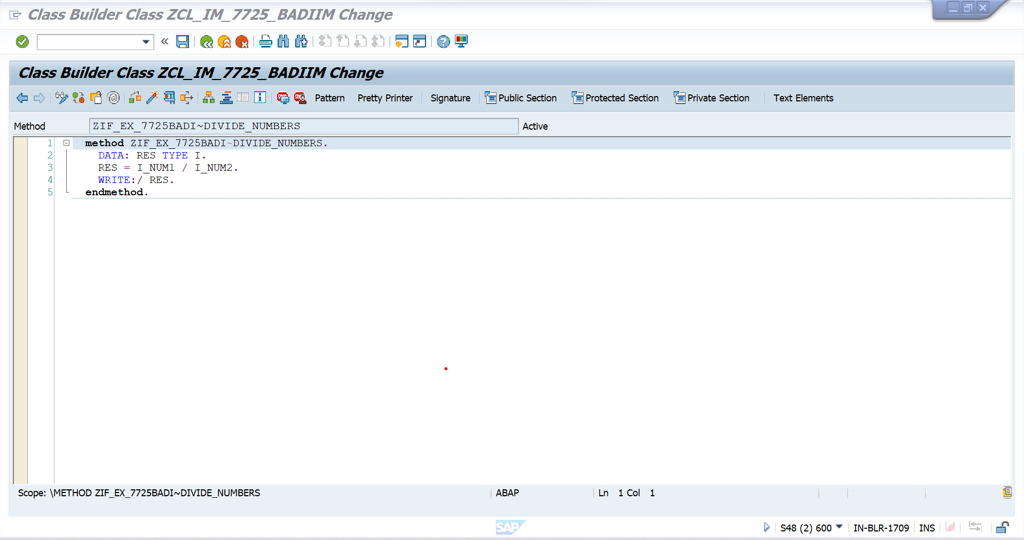

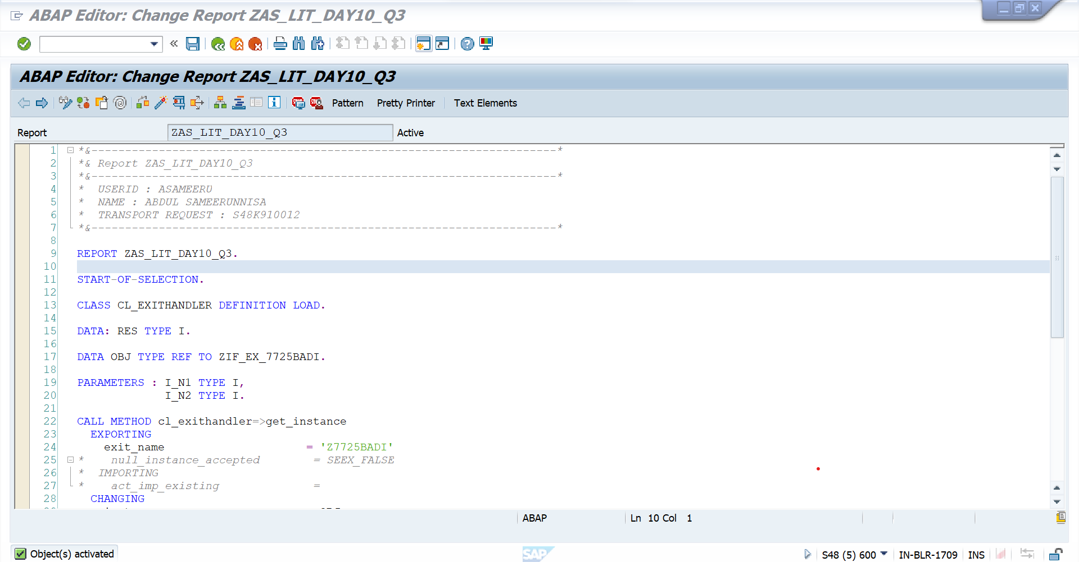

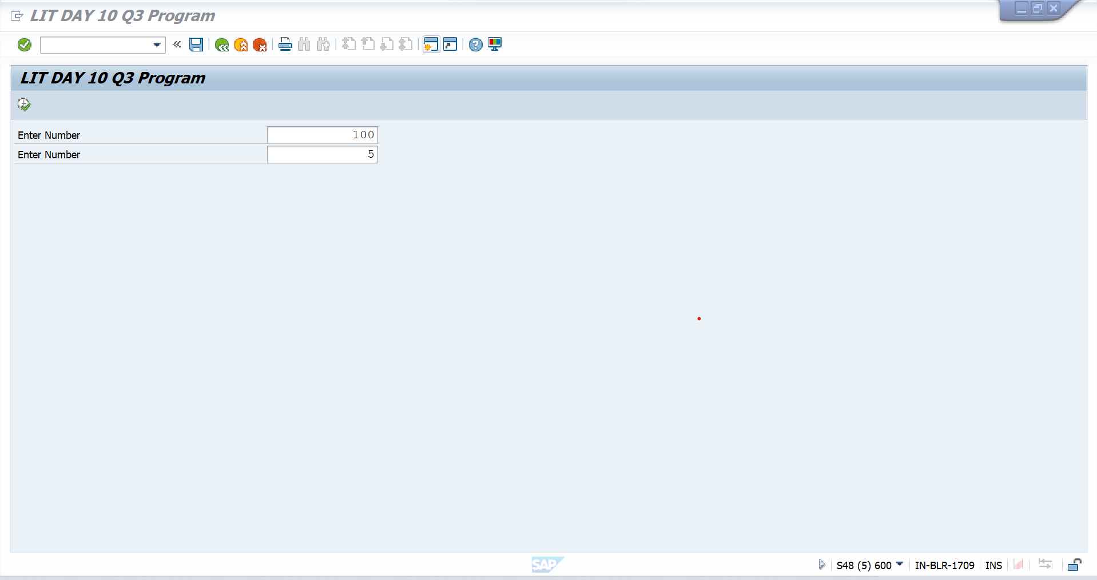

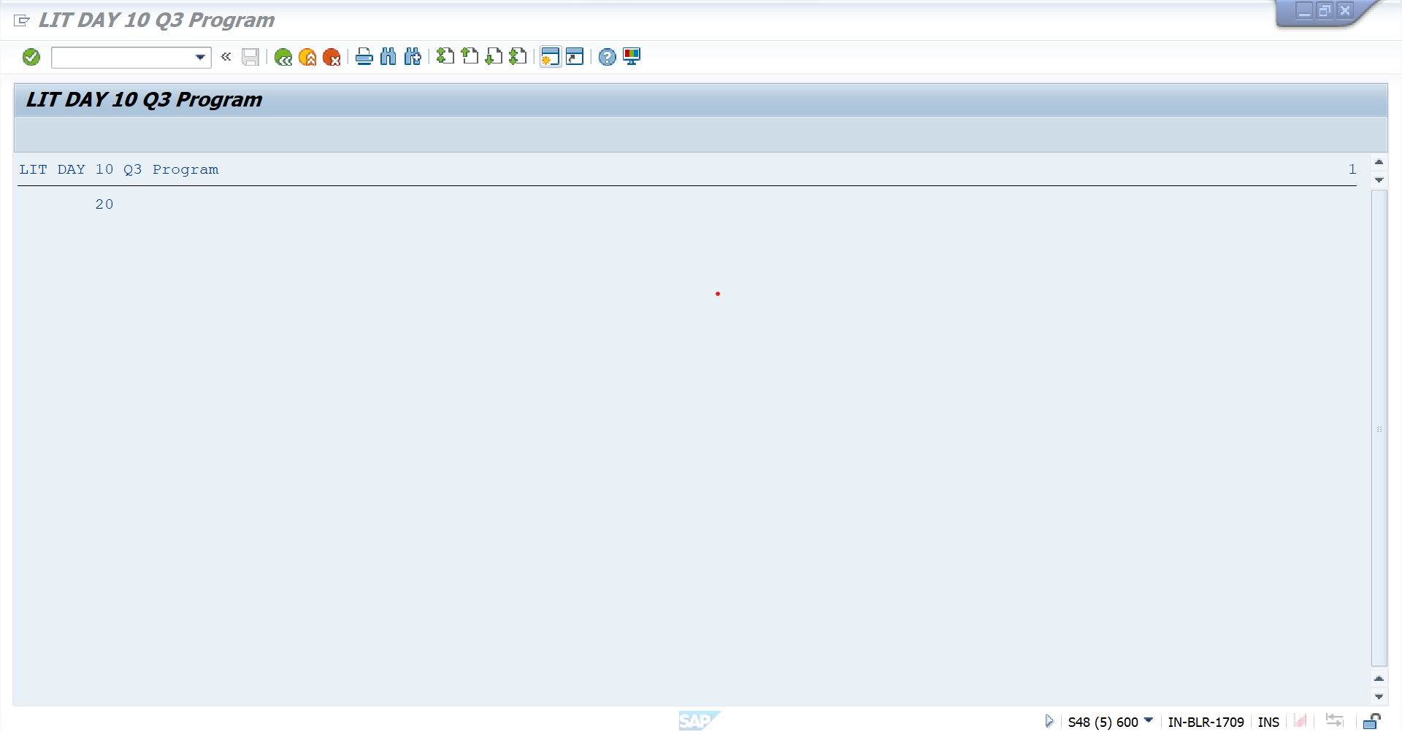

**Assignment 4 – Business Add in (BADI)-Multiple Use**

**Hint:**

1. **SE18 should be used to define a BADI**
2. **SE19 should be used to implement the BADI Definition.**

**Requirement:** Define and implement a custom BADI in SE18 to get Booking Data & Emailid.

Step1: Define a BADI (ZBADI_DEMO_01…05) in SE18.

Step2: Double click on the interface created to define the methods, parameters and exceptions.

Step3: Input Carrid & Connid Table SCARR Get, Email Data.

Step4: Input Carrid & Connid Table SBOOK Get Booking Data.

Step5: Define an exception if no data is present.

Step6: Create an implementation (ZBADI_DEMO_IMP_01...05) by specifying the BADI name that was created in step1.

Step7: Create a wrapper program (ZDEMO_BADI_01…05).

Step8: Define a reference variable of type BADI interface.

Step9: Define selection screen with two parameters of type integers

Step10: Call method GET_INSTANCE of the class CL_EXITHANDLER to get the BADI instance

Step11: Call method DIVIDE_NUMBERS using this instance and pass the two selection parameters.

Create a program to display Data of Sflight

CARRID

CONNID

FLDATE

PRICE

CURRENCY

PLANETYPE

SEATSMAX

**URL-SCARR---(From Badi)**

**BADI : Z7725BADI2**

**Report : ZAS_LIT_DAY10_Q4**

